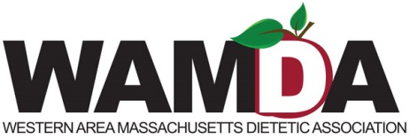

Save the Date

Please join us for the next WAMDA Program:
Nutrition from the ground up: an intuitive guide to cultivating a sustainable food practice

Description:
Nicole Cormier, RD, LDN is excited to share her journey into sustainability with you. Nicole's passion for nutrition counseling and the local food movement led to her involvement in a variety of projects, all of which have enriched her practice, her clients’ outcomes, and her own life. Come hear about her collaboration with local farmers, explore sustainable food opportunities for RDs, and learn about the benefits of local food sources.
From:
5:30-8:00

On:
9/9/15

Location:
Dakin room at Cooley Dickinson Hospital
Dinner to be provided

RSVP deadline:
August 26, 2015

RSVP contact:
Nicole Knee (413) 794-8897 or Nicole.Knee@baystatehealth.org

Cost:
WAMDA Members: $20, non-members: $25. Students and interns: $10
Checks payable to WAMDA
c/o Nicole Knee 195 Pleasant St. East Longmeadow, MA 01028
413-794-8897

