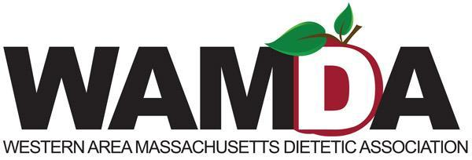

November 2020

Dear Supporter,

Every March the Western Area Massachusetts Dietetic Association (WAMDA) holds the Annual WAMDA 5K Run/Walk to celebrate health, National Nutrition Month, and raise funds for The Food Bank of Western Massachusetts. This year more than ever, members of our community are struggling and need our help to make it through these difficult times. The Run/Walk will be held virtually in March, with runners and walkers being able to complete the event on their own time any day from March 1 to March 10, 2021.

For the past 27 years, this event has joined the fight against hunger in our local community as well as increased awareness of healthful nutrition and fitness. The WAMDA 5K Run/Walk has drawn over 250 runners, walkers and supporters annually. Since the first race in 1993, we have raised over $80,000 and have distributed that money to different agencies to help our neighbors in need. For every $1 donated, The Food Bank of Western Massachusetts is able to provide 4 meals to neighbors in need. You can make a difference.

We would like to invite you to join us as a sponsor for our 28th Annual Virtual WAMDA 5K Run Walk race. We have attached a sponsorship proposal for your consideration. Remember, all money raised to support The Food Bank stays in Western Massachusetts.

Yours in good health,

Katie Defoe-Raymond, MS, RD, LDN
WAMDA 5K Sponsorship Coordinator
413-575-3048 (cell phone)
katie.defoe.wamda5krunwalk@gmail.com

