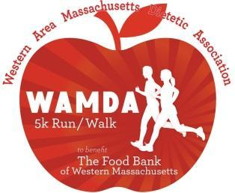
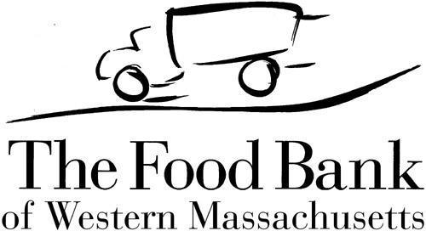

30th Annual WAMDA 5K Run/Walk
Proceeds Benefit The Food Bank of Western Massachusetts!

Run/Walk: In-person at Look Park in Northampton on March 4, 2023
Sponsorship Opportunities:
Platinum: $1000.00
- Listed as event sponsor on WAMDA website with link to company website
- Company name/logo on event T-shirt
- Eight complimentary Race Numbers to participate in 5K Run/Walk
- Opportunity to display signage at the event
- Listed as event sponsor on WAMDA 5K Facebook page
- Opportunity to include company information in runners tote bags
- Listed as a sponsor on press and media releases

Gold: $500.00
- Listed as event sponsor on WAMDA website with link to company website
- Company name/logo on event T-shirt
- Four complimentary Race Numbers to participate in 5K Run/Walk
- Opportunity to display signage at the event
- Listed as event sponsor on WAMDA 5K Facebook page
- Opportunity to include company information in runners tote bags

Silver: $300.00
- Listed as event sponsor on WAMDA website with link to company website
- Company name/logo on event T-shirt
- Two complimentary Race Numbers to participate in 5K Run/Walk
- Listed as event sponsor on WAMDA 5K Facebook page

Bronze: $150.00
- Listed as event sponsor on WAMDA website with link to company website
- Company name listed on event T-shirt
- One complimentary Race Number to participate in 5K Run/Walk

For questions: Katie Defoe-Raymond: Katie.Defoe.WAMDA5Krunwalk@gmail.com

30th Annual WAMDA 5K Run/Walk
Proceeds Benefit The Food Bank of Western Massachusetts!

Sponsorship Agreement:
□YES, we would like to sponsor! We have read the above agreement and would like to sponsor at the following level: (please circle one)

Platinum Gold Silver Bronze

□No, we cannot become a sponsor but please accept our monetary donation of: $_________
----------------------------------------------------------------------------------------------------------------------------
Sponsors at Bronze Donation Level or Higher:
- I would like to provide giveaways or swag to go in the bags for the runners/walkers: □YES □NO
---------------------------------------------------------------------------------------------------------------------------
All Sponsors: Please Complete Below:
Full Company Name (to be listed on the t-shirt):_____________________________________

Company Website: ___________________________________________________________

Company Representative Name:_________________________________________________

Representative Title:__________________________________________________________

Mailing Address:______________________________________________________________

Phone:______________________________ Email:__________________________________

Complete this form and send, with company/brand logo, to: Katie.Defoe.WAMDA5Krunwalk@gmail.com.
Note: Logos must be sent in either .eps or .ai format (camera ready vector).

Payment Options:
PayPal – go to https://www.wamda.org/events/wamda-5k-road-race for PayPal

Mail – Send check (payable to WAMDA 5K):
WAMDA 5K, c/o WAMDA
PO Box 934
West Springfield, MA 01090

Sponsorship form, payment and logo must be received by February 1, 2023. Once submitted, complimentary race registration information will be e-mailed to you.

