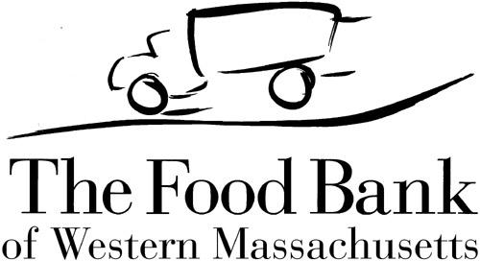
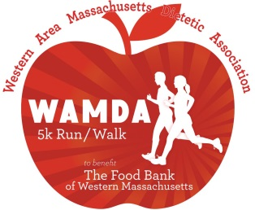
28th Annual WAMDA Virtual 5K Run/Walk
All Proceeds Benefit The Food Bank of Western Massachusetts!

Run/Walk Any Time From March 1 to March 10, 2021

Sponsorship Opportunities:
Platinum: $1000.00
- Listed as event sponsor on WAMDA website with link to company website
- Company name/logo on event t-shirt
- Company name/logo on race bib
- Eight (8) complimentary race registrations with event t-shirts
- Listed as event sponsor on WAMDA Facebook page
- Boosted company/brand highlight post or video on WAMDA Facebook page (Note: Video submitted by sponsor.)
- Listed as a sponsor on press and media releases

Gold: $500.00
- Listed as event sponsor on WAMDA website with link to company website
- Company name/logo on event t-shirt
- Company name/logo on race bib
- Four (4) complimentary race registrations with event t-shirts
- Listed as event sponsor on WAMDA Facebook page
- Boosted company/brand highlight post or video on WAMDA Facebook page (Note: Video submitted by sponsor.)

Silver: $250.00
- Listed as event sponsor on WAMDA website with link to company website
- Company name/logo on event t-shirt
- Two (2) complimentary race registrations
- Listed as event sponsor on WAMDA Facebook page

Bronze: $100.00
- Listed as event sponsor on WAMDA website with link to company website
- One (1) complimentary Race Number to participate in 5K Run/Walk
- Listed as event sponsor on WAMDA Facebook page

For questions please contact: Katie Defoe-Raymond: Katie.Defoe.WAMDA5Krunwalk@gmail.com

28th Annual WAMDA Virtual 5K Run/Walk
All Proceeds Benefit The Food Bank of Western Massachusetts!

Sponsorship Agreement:
□YES, we would like to sponsor! We have read the above agreement and like the benefits at the following level: (please circle one)

Platinum Gold Silver Bronze

□No, we cannot become a sponsor but please accept our monetary donation of: $_________

Full Company Name (to be listed on the t-shirt):_____________________________________

Company Website: ___________________________________________________________

Company Representative Name:_________________________________________________

Representative Title:__________________________________________________________

Mailing Address:______________________________________________________________

Phone:______________________________ Email:__________________________________

All Sponsors:

Complete this form and send, with company/brand logo, to: Katie.Defoe.WAMDA5Krunwalk@gmail.com.
Note: Logos must be sent in either .eps or .ai format (camera ready vector).

Payment Options:

PayPal – go to https://www.wamda.org/events/wamda-5k-road-race for PayPal

Mail – Send check (payable to WAMDA 5K):

WAMDA 5K, c/o WAMDA
PO Box 934
West Springfield, MA 10190

Sponsorship form, payment and logo must be received by February 1, 2021. Once submitted, complimentary race registration information will be e-mailed to you.

