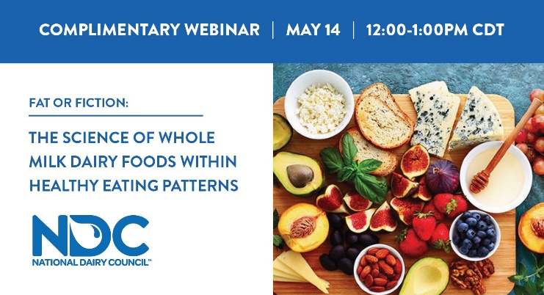

Attention health and wellness professionals! Join National Dairy Council on May 14 to explore emerging research on whole milk and whole milk dairy foods, indicating that there may be room for them to fit within healthy eating patterns that meet the overall calorie and fat recommendations of the Dietary Guidelines for Americans in a FREE CEU/CEC webinar. Expert speakers include Katie Brown, EdD, RDN, Matt Pikosky, PhD, RD and Leslie Bonci, MPH, RD, CSSD, LDN. Register here: https://bit.ly/2VA1C5j #dairynourisheslife #dairynourishesnetwork

