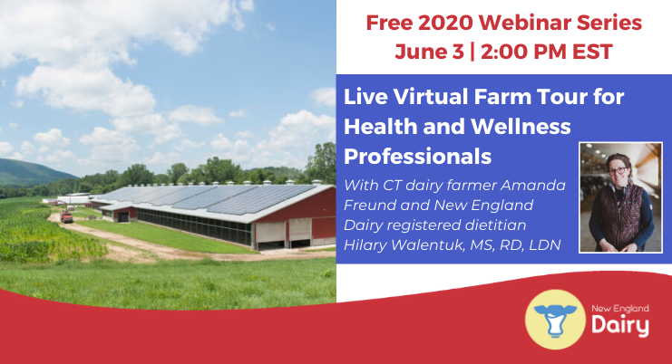

Live Virtual Farm Tour for Health and Wellness Professionals

Wednesday, June 3, 2020 at 2pm EST

Longer version:
New England Dairy’s free live Virtual Farm Tour on Wednesday, June 3 at 2 pm EST will connect health and wellness professionals directly to Freund’s Farm for a live video tour and chat with CT dairy farmer Amanda Freund and New England Dairy registered dietitian Hilary Walentuk MS, RD, LDN. Participants will walk away with a greater understanding of cow care, including cow nutrition, veterinary care, cow comfort, and milking technology; how New England dairy farmers are contributing to a sustainable food system, including reduction of greenhouse gas emissions and protection of soil and water; and milk safety including the use of antibiotics, hormones, and milk testing protocols. Participants will have the opportunity to send questions to be answered live by the dairy farmer and nutrition expert during the tour. Register here for this free webinar: https://bit.ly/2WHFCXQ

Approved for 1.0 hour of CPE by the Commission on Dietetic Registration.

