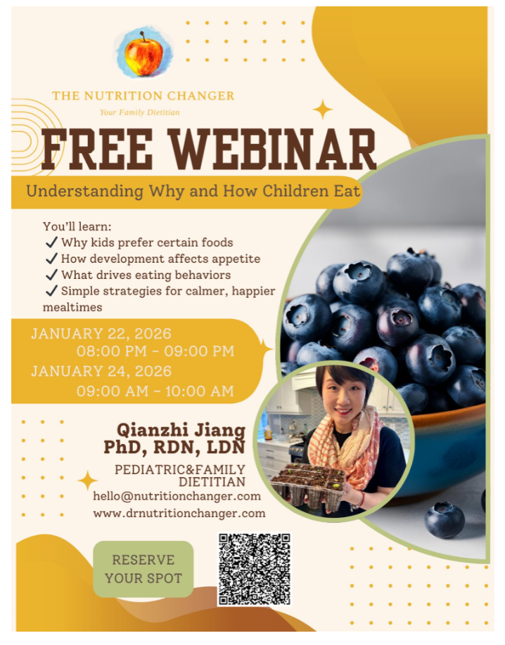
*This is not a WAMDA-Sponsored Event.

